**PRAKTIKUM PEMROGRAMAN 2**

Nama : Imam Sampurno Nugroho

Npm : 4511210002

mvn archetype:create -DgroupId=com.p2.regex -DartifactId=latihan-regex

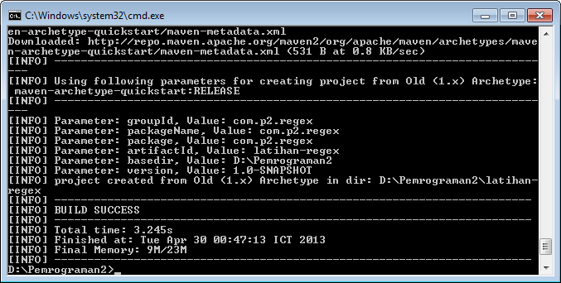

App.java

|  |
| --- |
| package com.p2.regex;  import java.util.regex.*;  public class App  {  public static void main( String[] args )  {  String text = "febry@yahoo.com";  String regex = "\\w+@\\w+\\.[a-zA-Z]{2,}";    if(text.matches(regex)){  System.out.println("email sesuai dengan regex");  }  else{  System.out.println("email tidak sesuai dengan regex");  }  }  } |

mvn clean package

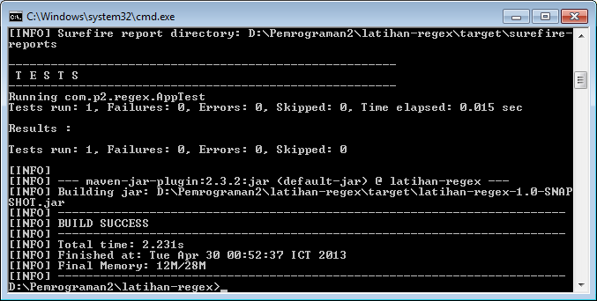

mvn exec:java -Dexec.mainClass=com.p2.regex.App

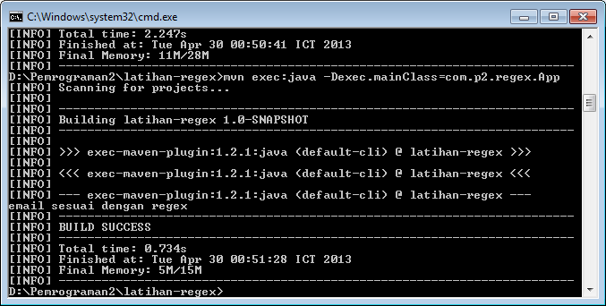

Cari.java

|  |
| --- |
| package com.p2.regex;  import java.util.regex.*;  public class Cari  {  public static void main( String[] args )  {  String text1 = "Nama saya Dono ini email saya Dono@yahoo.com";  cekRegex("[A-Z,a-z]{2,20}\\s",text1);  }  public static void cekRegex(String regexp,String kata){  Pattern p = Pattern.compile(regexp);  Matcher m = p.matcher(kata);    while(m.find()){  if(m.group().length() != 0){  System.out.println(m.group().trim());  }  System.out.println("index awal : "+m.start());  System.out.println("index akhir : "+m.end());  }  }  } |

mvn clean package

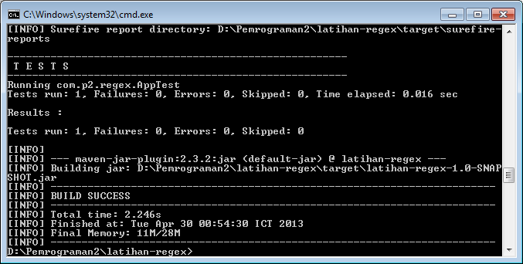

mvn exec:java -Dexec.mainClass=com.p2.regex.Cari

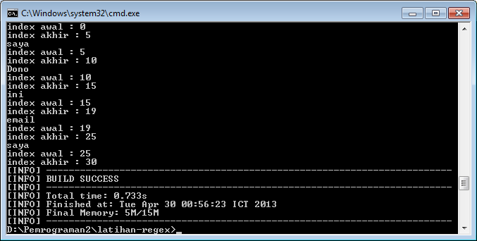

Tugas.java

|  |
| --- |
| package com.p2.regex;  import java.util.regex.*;  import java.lang.String;  import java.util.Scanner;  public class Tugas  {  public static void main( String[] args )  {  Scanner data = new Scanner(System.in);  System.out.println("Masukan Nama Anda");  String nama = data.nextLine();  String regexnama = "[A-Za-z]{1}[a-z]{2,}\\s?[A-Za-z]{0,1}[a-z]{0,}\\s?[A-Za-z]{0,1}[a-z]{0,}";  if(nama.matches(regexnama)){  System.out.println("Nama Anda Tidak Alay");  }  else{  System.out.println("Nama Anda Alay");  }    System.out.println("Masukan Nama Email");  String email = data.nextLine();  String regexemail1 = "[A-Za-z0-9]{1,}\\@?[A-Za-z]{1,}.[A-Za-z]{1,}.[A-Za-z]{1,}";  String regexemail2 = "[A-Za-z0-9]{1,}\\@?[A-Za-z]{1,}.[A-Za-z]{1,}";  if(email.matches(regexemail1) || email.matches(regexemail2)){  System.out.println("Email Anda Valid");  }  else{  System.out.println("Email Anda Tidak Valid");  }    System.out.println("Masukan Tanggal Lahir");  String lahir = data.nextLine();  String regexlahir = "[0-9]{1,2}-[0-9]{1,2}-[0-9]{4,}";  if(lahir.matches(regexlahir)){  System.out.println("Tanggal Lahir Valid");  }  else{  System.out.println("Tanggal Lahir Anda Tidak Valid");  }    System.out.println("Masukan Nama Situs");  String Situs = data.nextLine();  String regexsitus = "[A-Za-z0-9]{1,}.[A-Za-z0-9]{1,}.?[A-Za-z0-9]{0,}";  if(Situs.matches(regexsitus)){  System.out.println("Situs Valid");  }  else{  System.out.println("Situs Tidak Valid");  }    }  } |

Mvn clean package

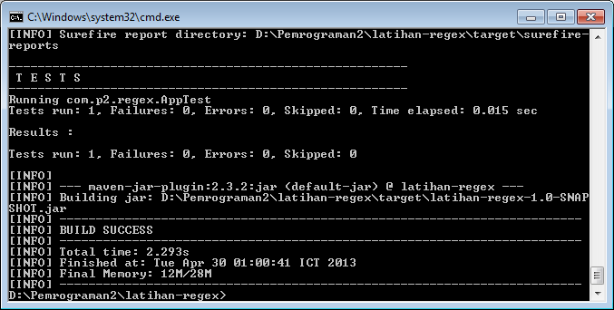

mvn exec:java -Dexec.mainClass=com.p2.regex.Tugas